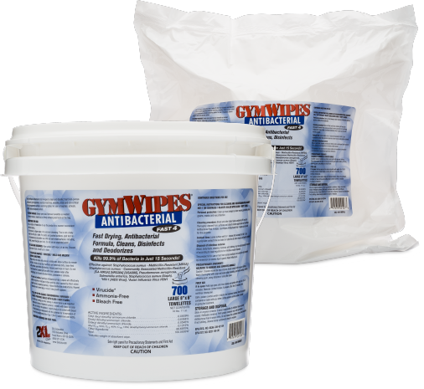
ANTI-Bacterial GymWipes are highly recommended by major equipment manufacturers to clean surfaces and equipment without harming them. Use them to wipe away dust, dirt, sweat, and fingerprints from any surface including touchscreens and electronics. Its low-reside, quaternary formula contains no alcohol, bleach, phenols or ammonia. Fast drying, antibacterial, cleans, disinfects and deodorizes all while killing 99.9% of bacterial in 15 seconds.
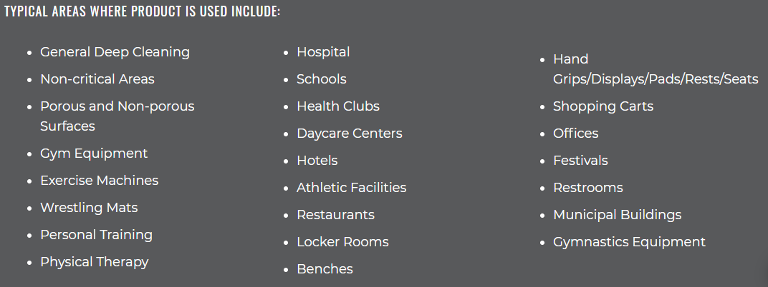
Available now and ready to go in our Warrensville Hts Showroom. For more information about Anti-Bacterial Wipes call 216-282-5880.
4555 Renaissance Parkway #103 Cleveland, Ohio 44128

